Building 1, Oxford & Glenhove Road, Houghton Estate, Johannesburg, 2198, South Africa. | • der Queries Phone: 087 283 2222  • Email: CIC@ccbagroup.com  • SMS: 36224 [1]
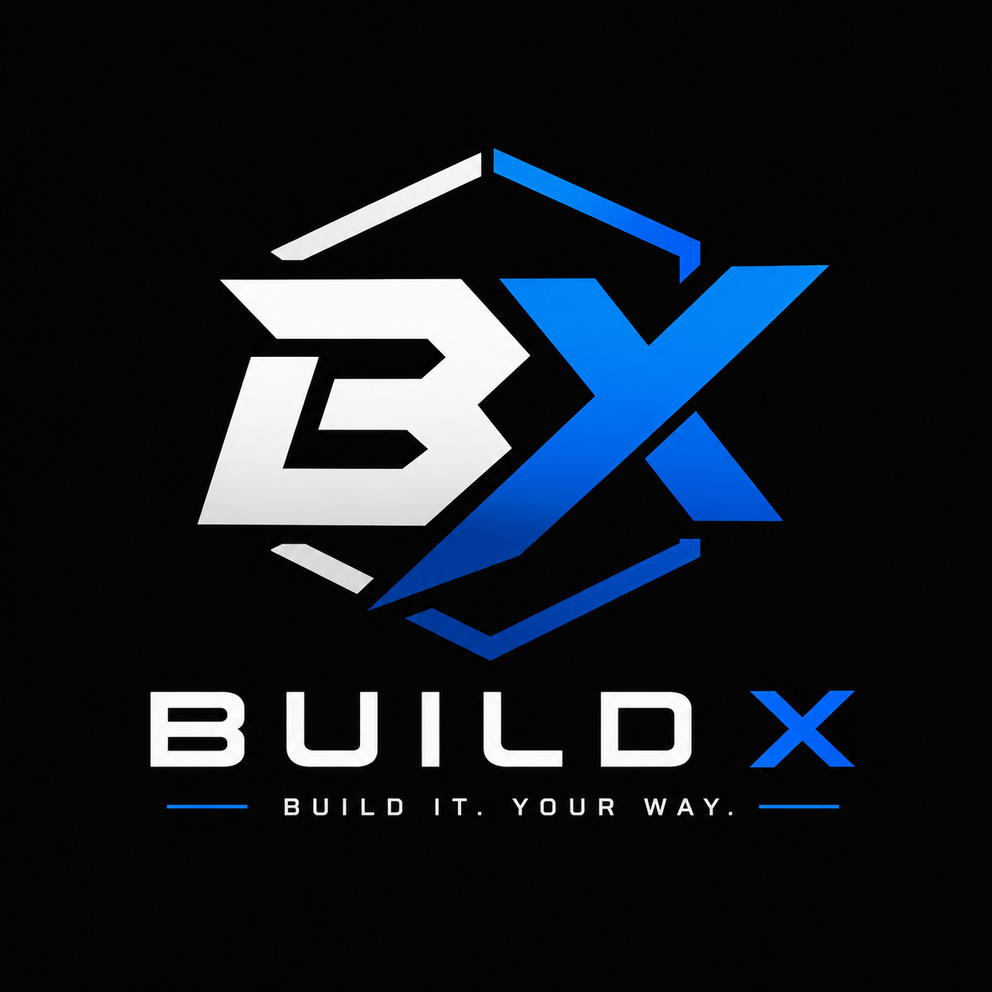

Build X
Houghton Estate, Johannesburg, 2198, South Africa.

We are excited to present you with the opportunity to become a sponsor for this organization. This organization celebrates. The purpose of the PC-selling website is to create an easy, convenient, and reliable online platform where customers can find and purchase computers that match their specific needs and budget.
This organization offers a unique opportunity for Build X to connect with tech enthusiasts and gain exposure through a series of tailored benefits. As a sponsor, you will be able to showcase your commitment to the pc community and enjoy a direct association with a positive and impactful experience.
Ultimately, the website aims to simplify the process of buying a PC by putting product information, pricing, comparisons, and purchasing options in one place.
Best regards,
Mbulelo Tsele

